Instructions to authors for the preparation of the manuscript

Pavel Novakª, Lubos Prochazka^{b} (13 points/bold face)
ªATZK, K Vodarne 531, 257 22 Cerčany, Czech Republic, asociacetz@asociacetz.cz
^{b}ECOSOND s.r.o., Krizova 1018, 150 00 Praha 5, Czech Republic, ecosond@ecosond.cz
(12 points, cursive letter)

Abstract (11 points/bold face, capital letters)

Abstract with key words and up to 300 words in Czech (Slovak) and English. Free paper abstracts will be included in the conference program.
Font type Times New Roman 12 points for the text. For the title of paper 16 points/bold face, capital letters, 13 points bold face for names of authors, 12 points for firms with addresses of authors. Number of pages:!! max. 8 pages including the abstract, pictures, tables and graphs!!.
(11 points)

1. Title of chapter

12 points/bold face, capital letters, leave one line, font type Times New Roman.

    - Title of sub – chapter
12 points/bold face, normal lettering
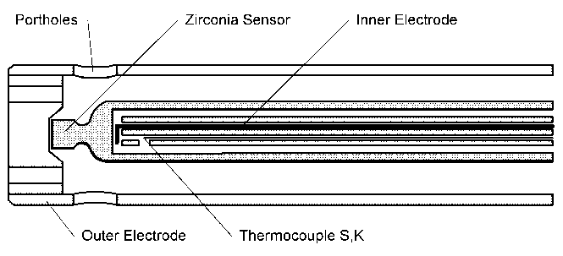
1.2 Pictures and tables
- format – jpg, gif, tiff, bmp
- figure captions place below the picture
- please do not use figures with company name etc
Figure captions should be placed below corresponding picture. Please leave one line free below the caption.
Fig.1. EGO sensor
Tables – please place the table on the appropriate place in the text, preferable at the same page at that is described. Put the name and description of the table below the table. Leave one line free below the table description.

Literature

Please number the literature consecutively, according their appearance in the text. Please summarize the literature at the end of your manuscript in the separate chapter “References”. Use the brockets [1] and not (1) for the numbering of the literature as in the text so in the list of the references.

[1] Novák, P., Patera, J. Hlediska chlazení u vakuových pecí. Hutnické listy, 1999, roč. 50, č.10, s. 8-14.
[2] Vráblík, F. Program pro výpočet tvrdosti oceli v závislosti na kalící schopnosti média. Sborník z konference Zabezpečení jakosti v provozech tepelného zpracování. Praha: ATZK, 2007, s. 29-35

Dead line for submission of your manuscript in electronic form (CD or per e-mail) is
September 30th, 2022. Format MS Word. Please keep that dead line, for later submission we can not ensure that the paper will be included in the Conference Proceedings.

Authors of papers are fully responsible for the quality of submitted materials, including possible grammar errors. The not conforming manuscripts to the instructions above will be returned to the author for corrections. Please read the manuscript carefully before submission.
Thank you.

www.htconference.cz

